COVID 19- Compliance Castle Cary Football Club
Parental/Carer Information sheet

We at Castle Cary Football Club understand that playing football is likely to look a bit different this season. We are doing whatever we can to ensure we adhere to the guidance created by the Government and the FA in order to be COVID-19 secure. We have created a Risk Assessment which outlines protocols for us all to adhere to. To access the Club’s Risk Assessment please go to our website www.castlecaryfc.co.uk.
On a practical level –
Please provide your child with a named water bottle and their own hand sanitiser with their name on it.
This Photo by Unknown Author is licensed under CC BY-SA
licensed under CC BY-SA
Your child will need to attend the football activity already changed and ready for exercise.
Please ensure your child knows how to maintain good hand hygiene.
Young players may need your support to understand the importance of social distancing as per Government requirements.

Spectators should remain socially distanced in accordance with Government guidance when attending any training/matches.
When attending training/matches you will asked to provide your contact details on entry to the training ground or pitch. These details will be kept for 21 days and will only be used for the purpose of NHS Track and Trace.
We will still be accepting cash for match fees. It would be greatly appreciated if you could bring the correct money (£2) so the handling of cash can be kept to a minimum.
IMPORTANT
Before attending any football activity (training/matches) ALL players and spectators MUST complete a self-assessment of COVID-19 symptoms. Please use the chart below to help. When attending training/matches you will be asked to fill in a ‘Record of Attendance’ sheet, this is where you will need to declare that your child isn’t showing any COVID-19 symptoms before they participate in any football activity. If the player and/or someone in the same household checks positive for any of the COVID-19 symptoms they must stay at home and follow the relevant Government guidance.

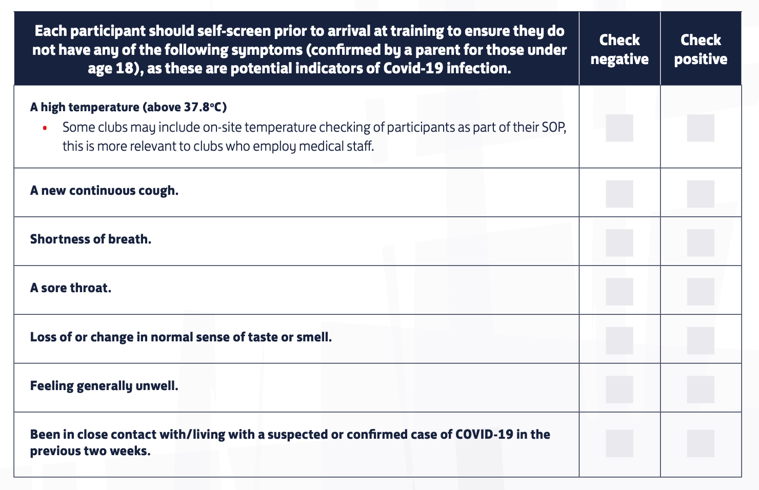

We hope your child enjoys playing football this season. Thank you in advance for playing your vital role in helping football get going again. We at Castle Cary Football Club look forward to working with you to ensure the transition back to grassroots football is as smooth and safe as possible.

Should you require further information please contact your child’s team Manager in the first instance.
Liam Wilton, U9’s Manager – 07469853739
Paul Lee – U12’s Manager - 07894090573
Tony Pike, U14’s and U11’s Manager - 07813946954
Alternatively, please contact Louise Jeans, Club Welfare officer – castlecaryfc.welfare@gmail.com
Kate Richards, Youth Secretary – castlecaryfc.juniors@gmail.co.uk
Neville Hartnell, Chairperson – hartnellneville2@hotmail.com

Useful resources on Club website – www.castlecaryfc.co.uk

CCFC Risk assessment
FA Football Activity Guidance for parents and carers
FA FAQ’s
FA First Aid Guidance
FA Guidance for Referees
FA A4 Summary sheet
Castle Cary FC Club Parent/Carer Information sheet
COVID -19 Self-Assessment chart
Club Membership/registration details – Club Membership form
Mini League form (ages U7’s to U12’s)
Youth League form (U13’s to U16’s)
Parents’ Parental/Carer Information sheet
Confirmation/permission to play in the current Pandemic situation
Payment details - CCFC BACS details.

