Castle Cary FC - COVID-19 Compliance

SELF-ASSESSMENT for COVID-19 Symptoms

Use before starting any football activity.

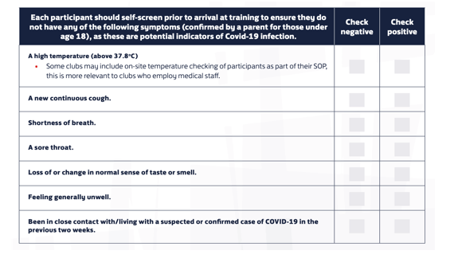

NOTE
IF ANYONE CHECKS POSITIVE FOR ANY SYMPTOMS THEY MUST RETURN HOME (IN A SAFE WAY) AND SEEK THE RELEVANT GOVERNMENT GUIDANCE. THEY SHOULD NOT BE ALLOWED TO CONTINUE WITH ANY FOOTBALL ACTIVITY.

PLEASE USE THE SHEET ATTACHED TO RECORD THE NAMES OF ANY PLAYERS THAT CHECK POSITIVE AND INFORM NEVILLE HARTNELL.

REGISTER OF NAMES OF PLAYERS WHO CHECK POSITIVE WHEN ATTENDING FOOTBALL ACTIVITY

NAME | DATE | SENT HOME (IN A SAFE WAY)? Y/N

